**Renault Kwid CLIMBER**

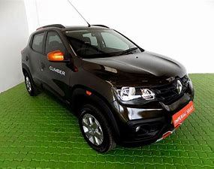

**Renault Kwid CLIMBER 1.0 AMT [2019-2020]**

Renault Kwid CLIMBER 1.0 AMT [2019-2020] is the top model in the Kwid lineup and the price of Kwid top model is ₹ 4.95 Lakh. This CLIMBER 1.0 AMT [2019-2020] variant comes with an engine putting out 67 bhp @ 5500 rpm and 91 Nm @ 4250 rpm of max power and max torque respectively. Renault Kwid CLIMBER 1.0 AMT [2019-2020] is available in transmission and offered in 6 colours: Zanskar Blue, Electric Blue, Outback Bronze, Moonlight Silver, Fiery Red and Ice Cool White.

**Specifications & Features**

* **Engine & Transmission**

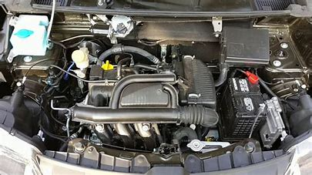

* + Engine

999cc, 3 Cylinders Inline, 4 Valves/Cylinder, DOHC

* + Engine Type

1.0L

* + Fuel Type

Petrol

* + Max Power (bhp@rpm)

67 bhp @ 5500 rpm

* + Max Torque (Nm@rpm)

91 Nm @ 4250 rpm

* + Mileage (ARAI)

24 kmpl

* + Drivetrain

FWD

* + Transmission

AMT - 5 Gears

* + Emission Standard

BS 4

* **Dimensions & Weight**
  + Length

3731 mm

* + Width

1579 mm

* + Height

1474 mm

* + Wheelbase

2422 mm

* + Ground Clearance

184 mm

* **Capacity**
  + Doors

5 Doors

* + Seating Capacity

5 Person

* + No of Seating Rows

2 Rows

* + Bootspace

300 litres

* + Fuel Tank Capacity

28 litres

* **Suspensions, Brakes, Steering & Tyres**
  + Front Suspension

Mac Pherson strut with lower transberse link

* + Rear Suspension

Twist beam Suspension with coil spring

* + Front Brake Type

Disc

* + Rear Brake Type

Drum

* + Minimum Turning Radius

4.9 metres

* + Steering Type

Power assisted (Electric)

* + Wheels

Steel Rims

* + Spare Wheel

Steel

* + Front Tyres

165 / 70 R14

* + Rear Tyres

165 / 70 R14

* **Features**
* **Safety**
  + Airbags

2 Airbags (Driver, Passenger)

* + Seat Belt Warning

Yes

* **Braking & Traction**

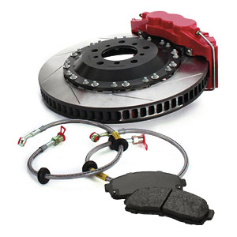

* + Anti-Lock Braking System (ABS)

Yes

* + Electronic Brake-force Distribution (EBD)

Yes

* **Locks & Security**
  + Engine immobilizer

Yes

* + Central Locking

Remote

* + Speed Sensing Door Lock

Yes

* + Child Safety Lock

Yes

* **Comfort & Convenience**
  + Air Conditioner

Yes (Manual)

* + Front AC

Common Fan Speed Control

* + Heater

Yes

* + Parking Assist

Reverse Camera

* + Parking Sensors

Rear

* + 12V Power Outlets

2

* **Seats & Upholstery**

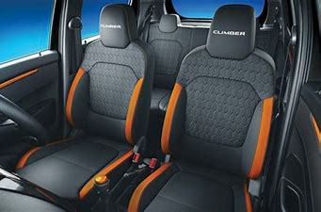

* + Driver Seat Adjustment

4 way manually adjustable (seat forward / back, backrest tilt forward / back)

* + Front Passenger Seat Adjustment

4 way manually adjustable (seat forward / back, backrest tilt forward / back)

* + Seat Upholstery

Fabric

* + Rear Passenger Seats Type

Bench

* + Interiors

Dual Tone

* + Rear Armrest

Yes

* + Folding Rear Seat

Full

* + Front Seatback Pockets

Yes

* + Head-rests

Front & Rear

* **Storage**
  + Cup Holders

Front Only

* **Doors, Windows, Mirrors & Wipers**
  + Power Windows

Front & Rear

* + Adjustable ORVM

Externally Adjustable

* + Exterior Door Handles

Black

* + Interior Door Handles

Black

* + Door Pockets

Front

* + Boot-lid Opener

Internal

* + Outside Rear View Mirrors (ORVMs)

Black

* **Exterior**
  + Roof rails

Yes

* + Roof Mounted Antenna

Yes

* + Body-Coloured Bumpers

Yes

* + Body Kit

Cladding - Black/Grey

* + Rub - Strips

Black

* **Lighting**

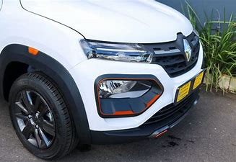

* + Fog Lights

Halogen on front

* + Daytime Running Lights

LED

* + Headlights

Halogen

* + Tail Lights

Halogen

* + Cabin Lamps

Centre

* **Instrumentation**
  + Instrument Cluster

Digital

* + Trip Meter

Electronic 2 Trips

* + Average Fuel Consumption

Yes

* + Average Speed

Yes

* + Distance to Empty

Yes

* + Clock

Digital

* + Low Fuel Level Warning

Yes

* + Tachometer

Digital

* **Entertainment, Information & Communication**

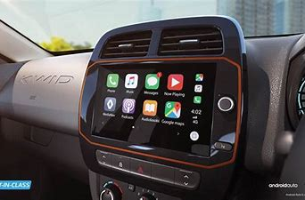

* + Integrated (in-dash) Music System

Yes

* + Head Unit Size

2 Din

* + Display

Touch-screen Display

* + GPS Navigation System

Yes

* + Speakers

2

* + USB Compatibility

Yes

* + Aux Compatibility

Yes

* + Bluetooth Compatibility

Phone & Audio Streaming

* + MP3 Playback

Yes

* + AM/FM Radio

Yes

* + Voice Command

Yes

* **Manufacturer Warranty**
  + Warranty (Years)

2

* + Warranty (Kilometres)

50000

Verients

colours

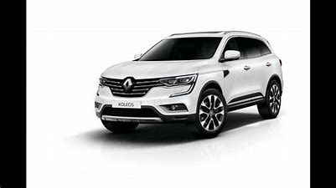

Moonlight Silver

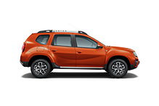

Electric Blue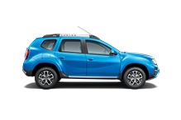

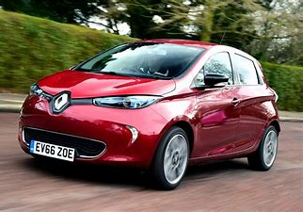

Fairy Red